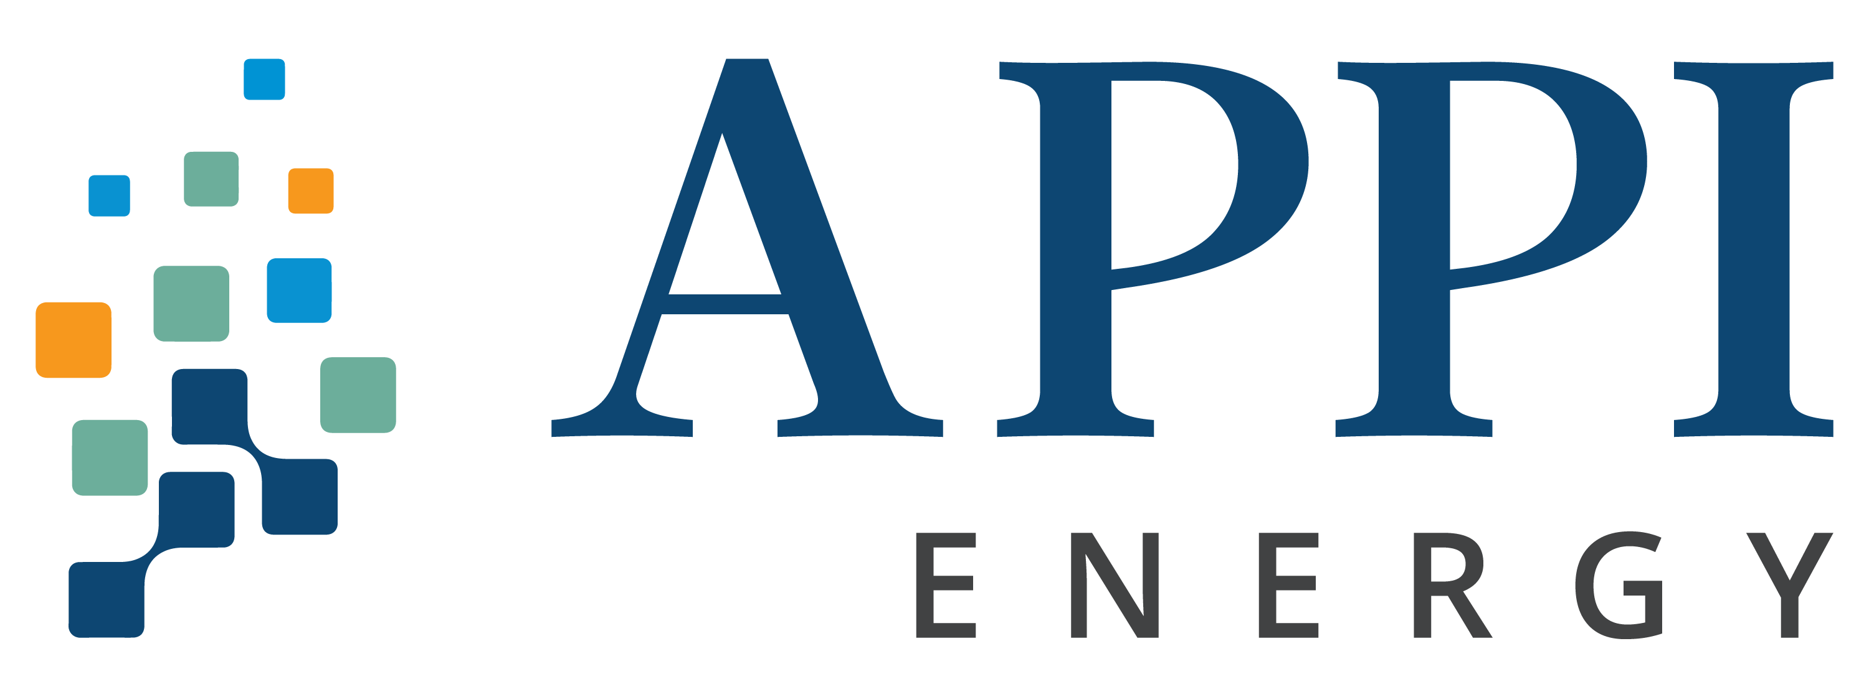Benefits of an LED Lighting Retrofit Project

If you’ve been toying with the idea of implementing LED lighting efforts in your facility, then now is the perfect time to take pause and home in on the benefits and relative ease of an LED lighting retrofit. From better lighting and improved safety, to significant cost savings, the question shouldn’t be IF it is time for an LED lighting retrofit, but WHEN.

Brighten Your Perspective
First things first, considr the numerous benefits that a LED retrofit will bring in tow:

- Improved Energy Efficiency
LED lighting provides better, cleaner lighting at a fraction of the energy cost of traditional lighting. LEDs are significantly more efficient than their older counterparts, providing better light with less than half as much power consumption as standard high-pressure sodium (HPS) or Metal Halide (MH) lights.

- Reduce Energy Costs
Lighting is one of the largest electricity expenses, which is why upgrading your facility to LEDs is one of the smartest investments you can make. Upgrading to LEDs can reduce your energy lighting costs, but even better, with the cost savings and potential incentives and rebates, you’re looking at a quick ROI too.

- Capture Tax Incentives & Rebates
Depending on what state your facility is located, LED lighting projects can qualify for rebates, tax incentives and grants, for example, businesses in Maryland were eligible for up to 70% of the total project cost as well as federal tax deductions of up to .60 cents per square foot in 2020.

- Improve Lighting Quality, Safety and Productivity
LED lighting is bright and crisp, which not only improves the lighting environment of your facility but can also improve the perimeter lighting of your building or parking lot, resulting in increased safety for pedestrians and drivers. In addition to increased safety, there have been studies that indicate that better-quality LED lighting can increase efficiency and productivity as well as improve employee morale.

- Reduce Recurring Maintenance Costs
With our program, all the LEDs are guaranteed for at least five years, eliminating on-going maintenance costs. The result? You’re able to reduce costs with no operational disruption, and in many cases, no upfront capital.

Proven Results
The most common roadblock businesses voice are: not wanting to invest the upfront capital to fund the project, and not having the bandwidth to perform the tasks needed to complete a retrofit.

Case Study #1: A leading North American contract candy manufacturing company saw a unique opportunity to capitalize on substantial energy and maintenance savings through improved LED lighting practices. In addition to needing innovative ways to upgrade lighting throughout their facility while simultaneously taking advantage of energy-saving rebates, they were also eyeing improved perimeter lighting for enhanced security.

Project Snapshot:
- On Bill Funding
- First Year Energy Cost Savings: $144,734
- Rebate Secured: $54,211
- Section 179 Tax Write-Off: $74,443
- Annual Energy Savings: 1,084,222 kWh
Case Study #2: A large custom label printer was in need of improved lighting over their machines, with an aim to also save money, increase efficiency in their facilities, and provide a more sustainable business for their customers. In addition, they sought a solution that did not require upfront capital.
Project Snapshot:
- On Bill Funding
- First Year Energy Cost Savings: $109,557; ROI of 62.7%
- Rebate Secured: $33,000
- Annual Energy Savings: 913,768 kWh

Our Process
APPI Energy’s LED retrofit program provides businesses a trusted energy partner to assist them in economically replacing their current inefficient lighting with cost-effective, less-consumptive LED lighting. We provide a turnkey solution that sources products from reliable suppliers, manages the entire scope of the project, and secures rebates on the client’s behalf.

Allow APPI Energy to perform an initial facility assessment to determine if your organization is eligible for rebate incentives and assess the viability of the project. APPI Energy makes it easy for our clients to understand exactly what their rebates and savings can be. In many cases, a project can be completed with no capital expenditure on the part of the client.

In addition to those savings, APPI Energy also offers on-bill funding programs that allow qualified clients to have the entire project installed with no capital expense up front and then use the savings to pay for the project in monthly installments on their electric bill. You also have the option of keeping the rebate or rolling it into the project cost to reduce the payments even further.

One viable option for further exploring your answers to any and/or all of the above is by contacting the National Tooling and Machining Association’s endorsed energy consulting firm, APPI Energy. For more information, contact NTMA’s dedicated Energy Consultant, Noel Temple, at 667.330.1159 or ntemple@appienergy.com.

