www.gonrl.org

• Attend local and national events to network with others in the industry

• Connect with NTMA and others in the industry on Twitter and LinkedIn

• Gain valuable access through an executive introduction with a potential customer or strategic partner



www.metalworkingadvocate.org

• Encourage future generations through   
the National Robotics League

• Help promote policies to ensure a strong manufacturing sector

• Stay current with the latest   
 developments

• Explore opportunities for developing your workforce

• Educate your workforce through our innovative NTMA-U program

• Test current and potential employees with

our online aptitude test



• Meet with buyers from OEMS and Tier 1 and Tier 2 companies at our Purchasing Fairs

• Save money with NTMA discount   
programs available through our   
Affinity Partners

• Gain valuable insight with our   
Business Conditions Report

• Streamline your operations through our Legal   
 services and HR resource library

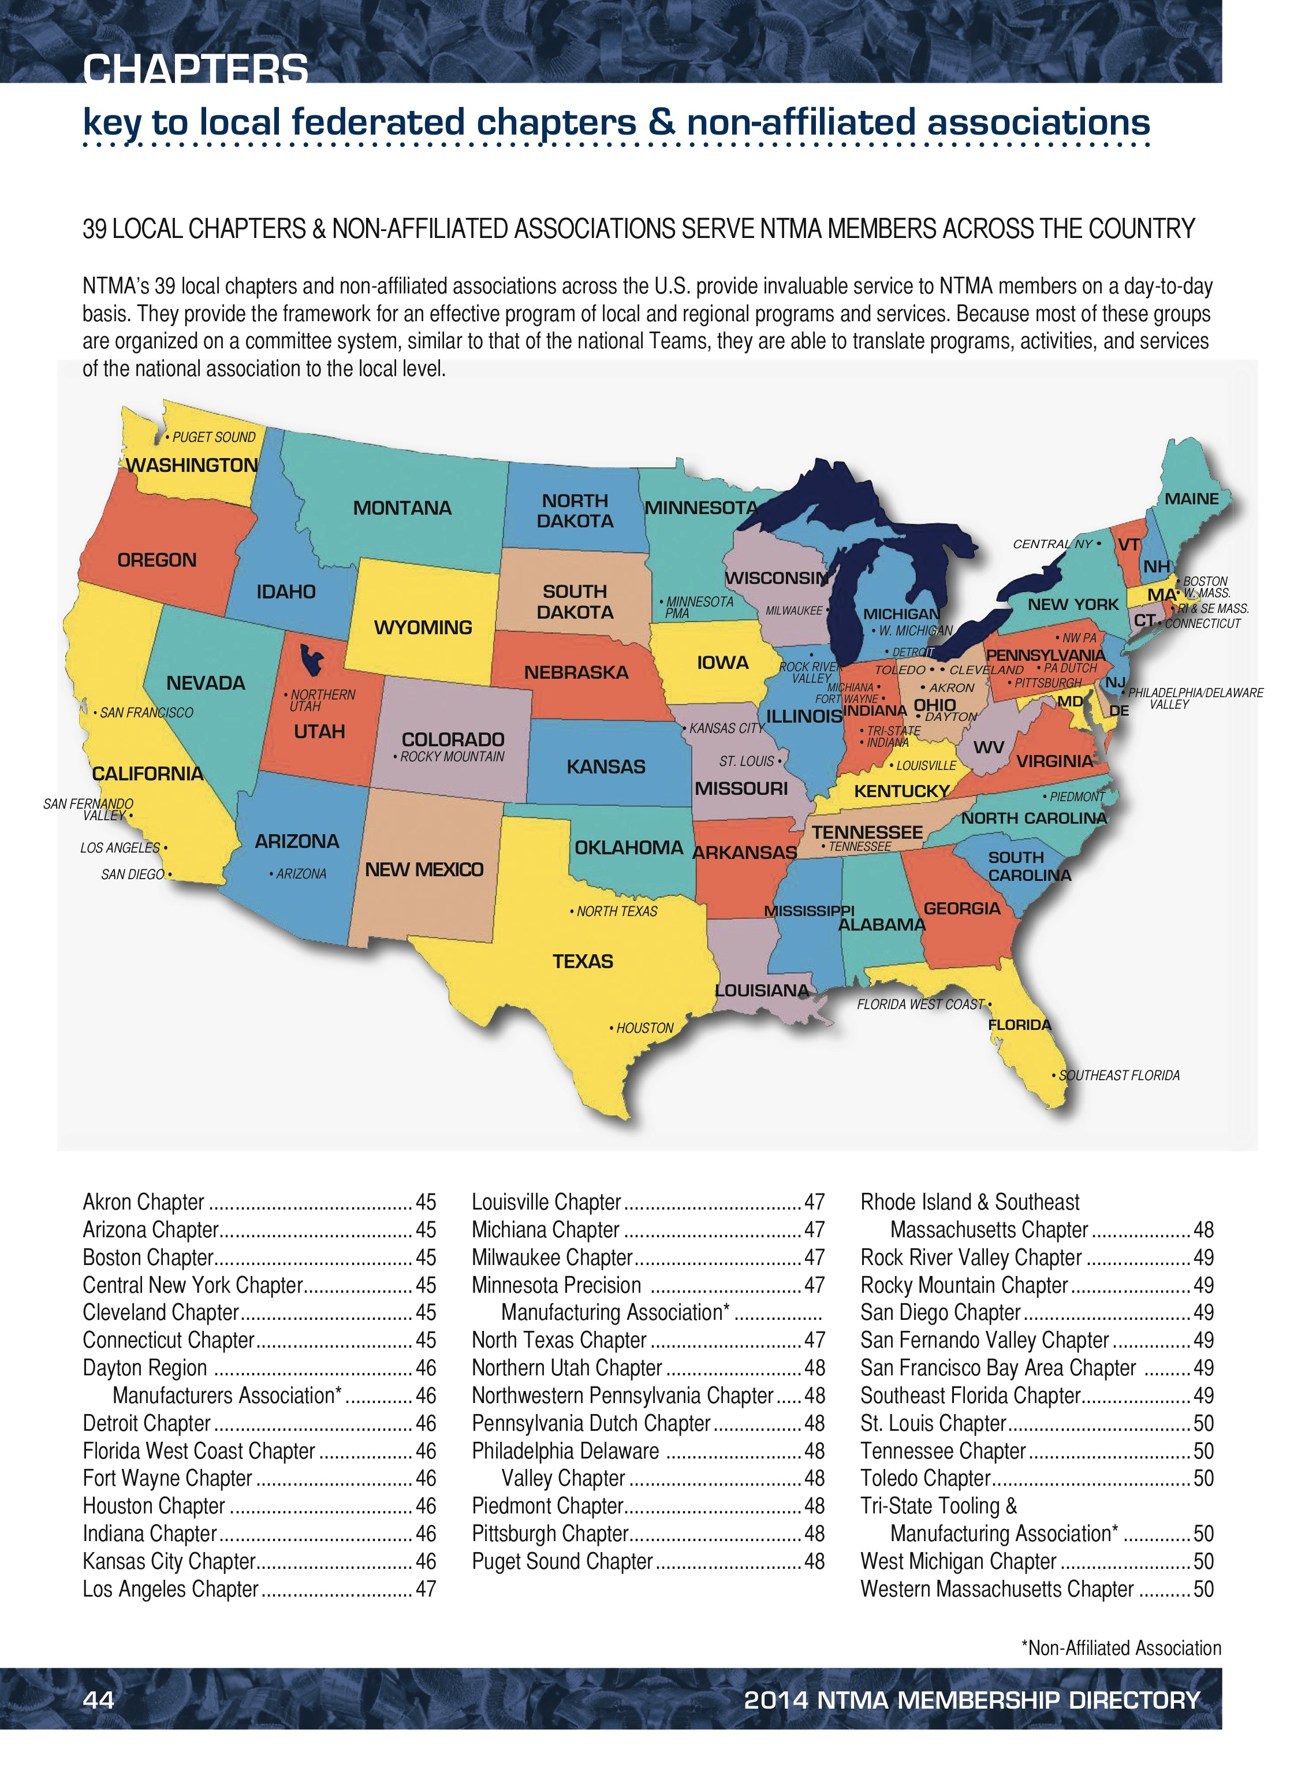

INSERT CHAPTER VALUE

INSERT CHAPTER VALUE

INSERT CHAPTER VALUE

INSERT CHAPTER VALUE

TO APPLY FOR

MEMBERSHIP

VISIT:

INSERT CHAPTER WEBSTIE HERE

P: 123.456.7890

F: 123.456.7890

E: [email@here.org](mailto:email@here.org)

Social Media Here

Chapter Name

Address

City, State Zip

INSERT CHAPTER LOGO HERE