Improving Profitabilty and Marketing Impact
Your keynote address and ability to translate the features into specific selling points was instrumental in the 33% increase in our sales efforts.
Bill Gaier, Manager, The Kansas City Star

You met every expectation of a rather diverse audience.
David Poole, Managing Principal, DeFrain Mayer

It was evident that your words and insight made an impact throughout the day. But the real measure of the impact you had was when your points were recounted -and enthusiastically discussed – 6 weeks after the fact!
Debra Calvert, Sales Training Manager, The Kansas City Star

Your creative, insightful comments helped us tap into new opportunities. Your pragmatic approach helped us tremendously.
George Cook, President & CEO, The First National Bank



Richard M. Delaney
Experienced ∗ Professional ∗ Marketer … With a sense of humor

As owner of 20/20 Marketing, Rich builds his presentations on his 30-year professional career which includes his management experience with three Fortune 500 companies: Caterpillar, Montgomery Wards, and ITT Corp., and his experience as a board member of various organizations. Rich’s consulting work has included productivity improvement assignments for major manufacturers, financial institutions, and service organizations. He has consulted with A&E Manufacturing, Children’s Mercy Hospital, Benchmark Biolabs, and other major organizations to help them achieve their goals. He has a unique insight into the critical issues of service excellence, seamless marketing, energizing employees, strategic tracking, and e-commerce. Rich’s entertaining, yet insightful, presentation topics include:

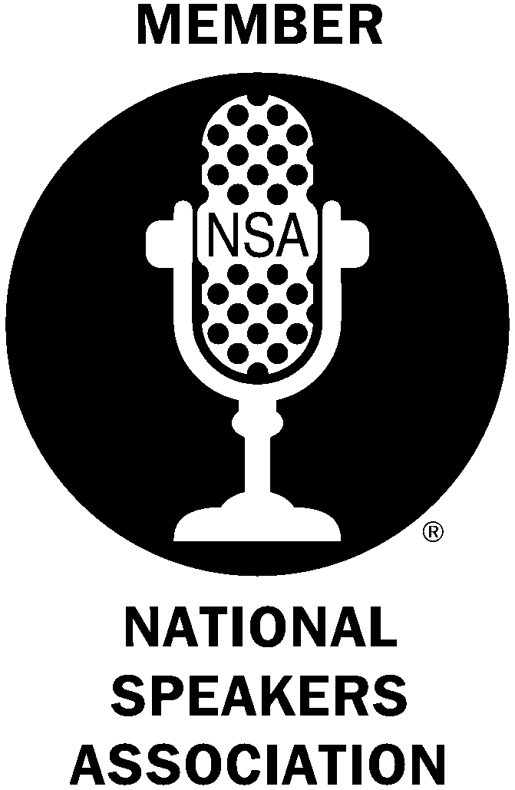
- Achieving Strategic Planning Success
- Selling Smarter
- How to Improve Top-Line Results
- Using Your Customers to Provide a Strategic Advantage

To help clients succeed, Rich successfully blends practical experience with his academic credentials which include: an MBA in finance from the University of Chicago, a Masters of International Marketing degree from the American Graduate School International Management (Thunderbird), and a Bachelor of Science degree in Operations Management from the University of Arizona.

He has written numerous articles on marketing, sales, and business strategy improvement. Rich’s new book, Power Up Your Selling Effectiveness!, provides insights on how to overcome common roadblocks with uncommon, but proven, success techniques.

To book Rich for your next management meeting, contact:

20/20 Marketing, 913-814-8742

